**MODUL**

**BAB III**

**EJB SESSION BEAN**

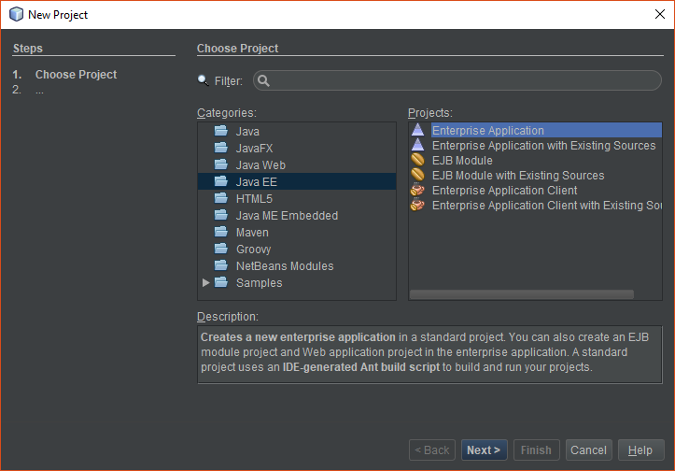

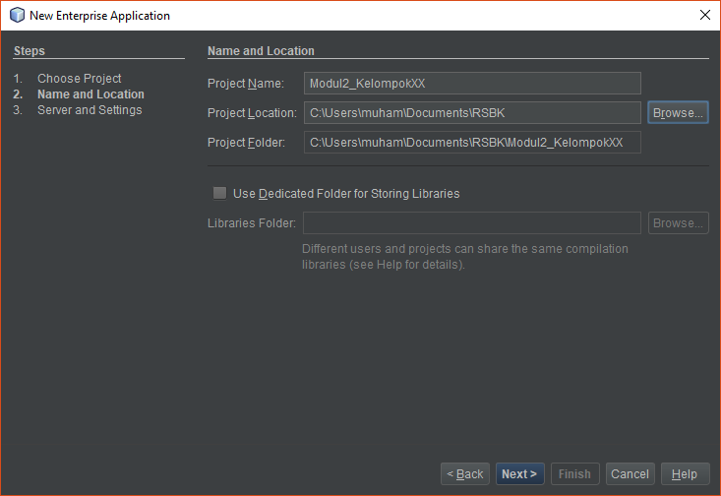

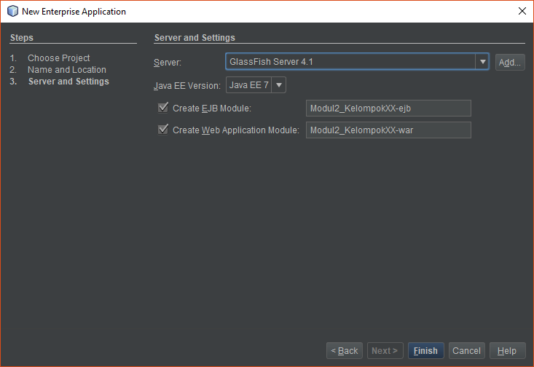

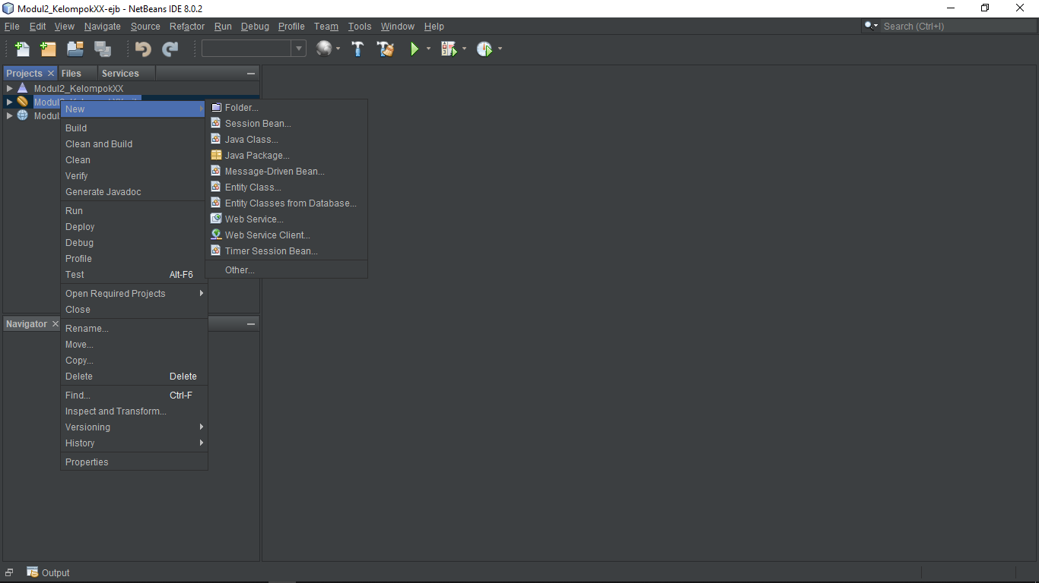

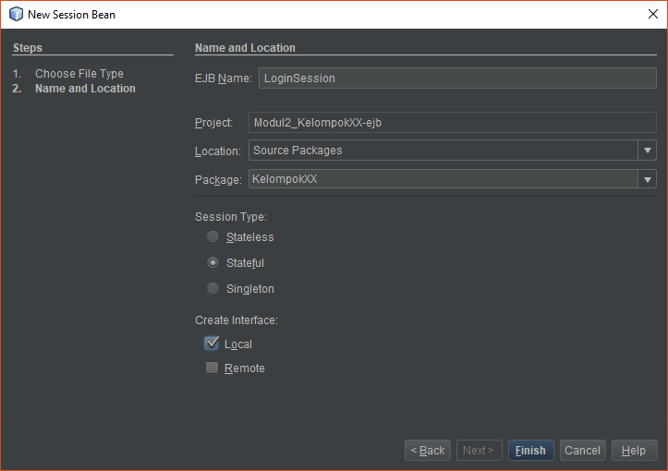

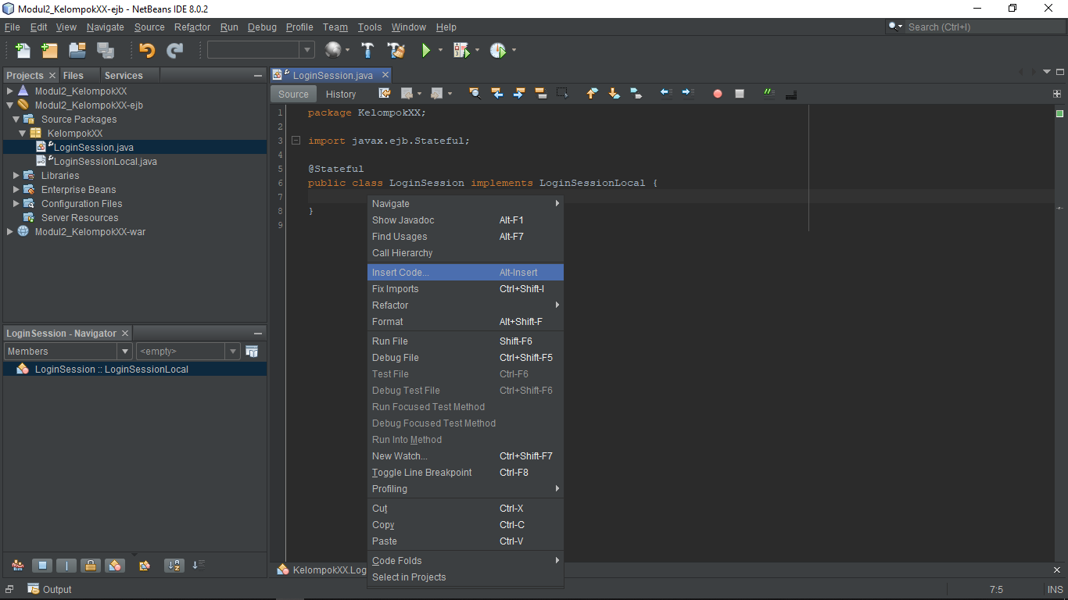

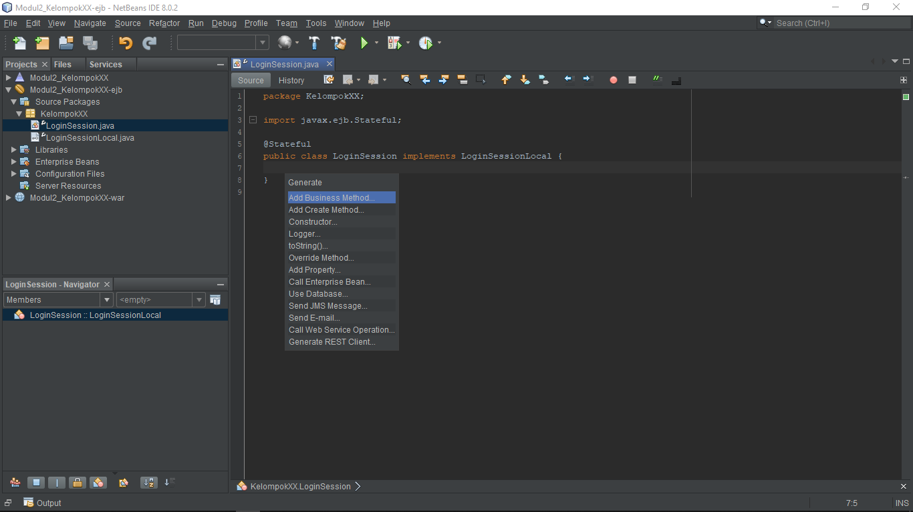

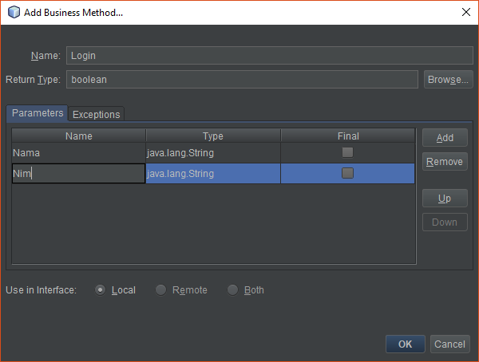

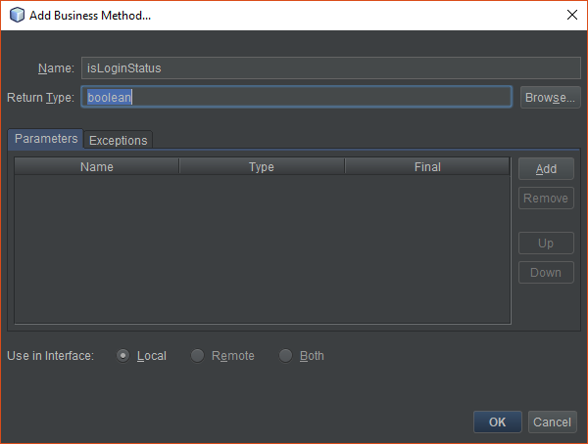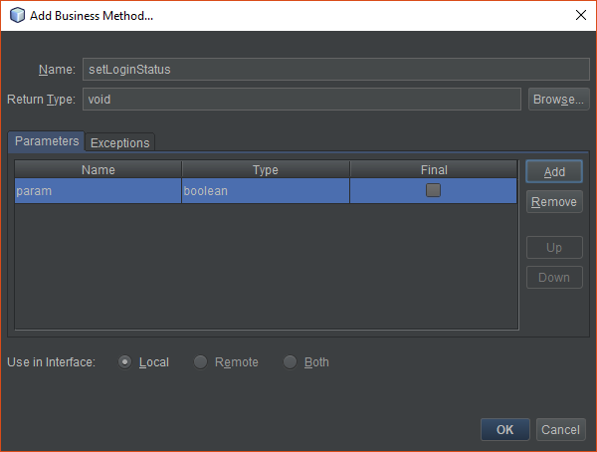

|  |
| --- |
| private final String [] Nama = {"Praktikum RSBK"};  private final String [] Nim = {"21120116000001"};  private boolean loginStatus = false;  @Override  public boolean Login(String Nama, String Nim) {  return Nama.equals(this.Nama[0]) && Nim.equals(this.Nim[0]);  }  @Override  public boolean isLoginStatus() {  return loginStatus;  }  @Override  public void setLoginStatus(boolean loginStatus) {  this.loginStatus = loginStatus;  } |

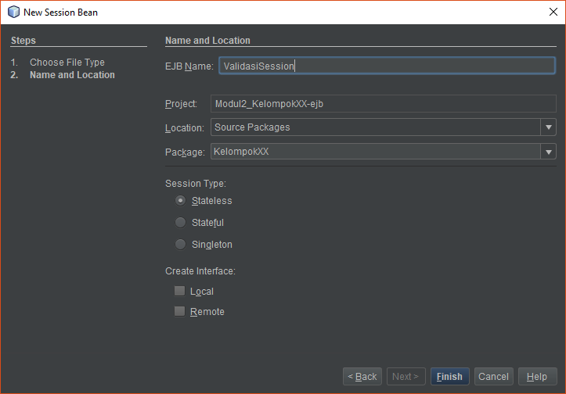

|  |
| --- |
| public boolean nama(String param) {  try{  if(param.isEmpty()){  return false;  }  if(param.length()<=5){  return false;  }  }catch(NullPointerException e){  return false;  }  return true;  }  public boolean nim(String param) {  try{  Long.parseLong(param);  }catch(NumberFormatException e){  return false;  }  if(param.isEmpty()){  return false;  }  if(param.length()<14){  return false;  }  return true;  } |

|  |
| --- |
| <!DOCTYPE html>  <html lang="en" dir="ltr">  <head>  <meta charset="utf-8">  <title>2020 Gelar ST</title>  </head>  <body>  <h1 style="text-align:center"> 2020 GELAR ST</h1>  <h3 style="text-align:center">Tahun depan kita wisuda</h3>  <h3 style="text-align:center">Pelajari program berikut biar bisa mewujudkannya</h3>  <h3 style="text-align:center;"><a href="Login" style="text-decoration:none"><< Klik Disini >></a></h3>  <h4 style="text-align:center">&copy; Copyright Praktikum Rekayasa Perangkat Lunak 2019</h4>  </body>  </html> |

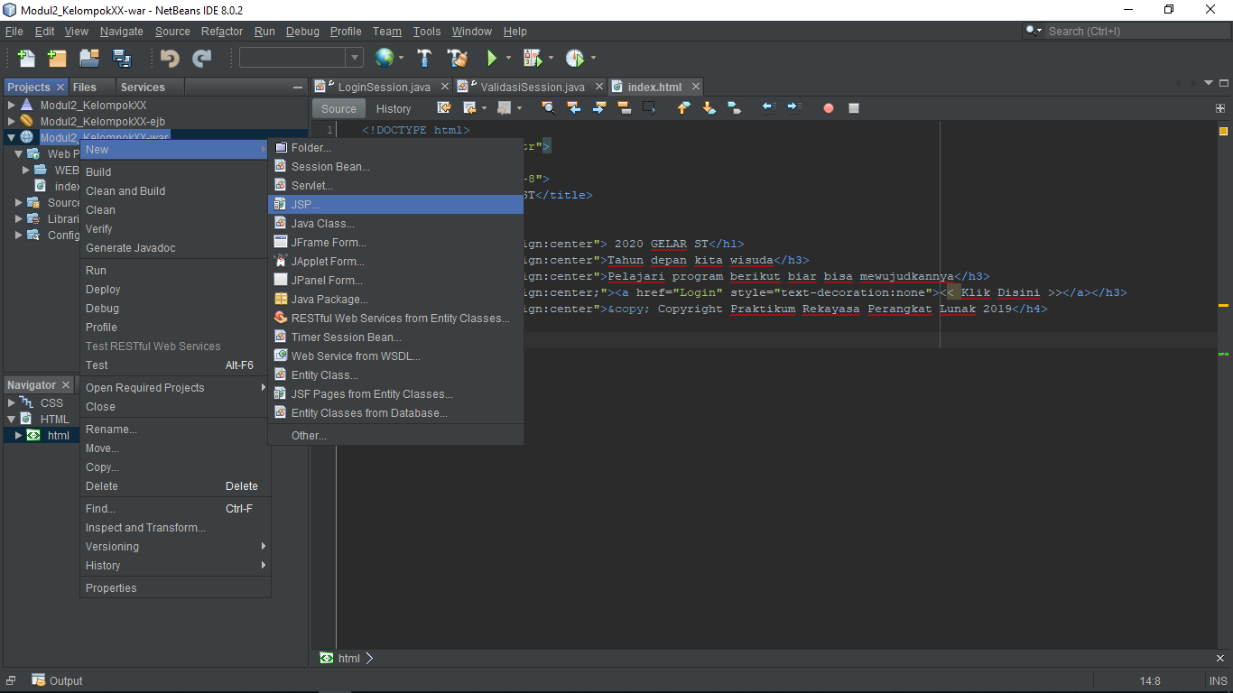

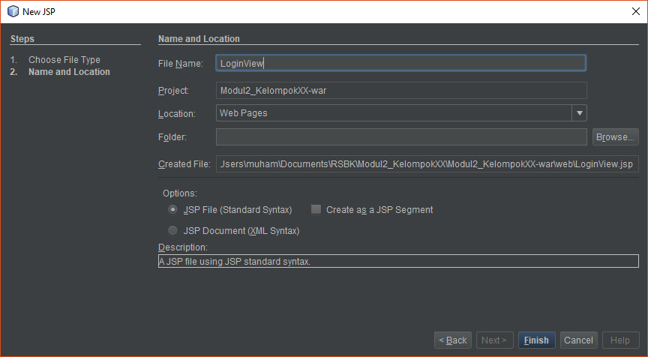

|  |
| --- |
| <%@page contentType="text/html" pageEncoding="UTF-8"%>  <!DOCTYPE html>  <html lang="en" dir="ltr">  <head>  <meta charset="utf-8">  <title>Tahun Depan Wisuda</title>  <meta name="viewport" content="width=device-width, initial-scale=1.0">  </head>  <body>  <header>  <h1 style="text-align:center">SEMANGAT, TAHUN DEPAN WISUDA</h1>  </header>  <main style="display:flex;justify-content:center">  <% String stat = (String)request.getAttribute("status");  if(stat != "true"){%>  <form action="Login" method="post" style="display:flex;justify-content:center;flex-direction: column;align-items: center;">  <label for="nama" style="margin-bottom:5px">Nama Mahasiswa</label>  <input id="nama" type="text" name="nama" placeholder="Nama Mahasiswa">  <span style="color:red">${namaEr}</span>  <br>  <label for="nim" style="margin-bottom:5px">NIM Mahasiswa</label>  <input id="nim" type="text" name="nim" placeholder="Nim Mahasiswa">  <span style="color:red">${nimEr}</span>  <span style="color:red">${userEr}</span>  <br>  <input type="submit" name="submit" value="Masuk" style="width:150px">  </form>  <%} else {%>  <form action="Login" method="post" style="display:flex;justify-content:center;flex-direction: column;align-items: center;">  <input type="submit" name="keluar" value="Keluar" style="width:150px">  </form>  <%}%>  </main><br>  <footer style="text-align:center">&copy; Copyright Praktikum Rekayasa Perangkat Lunak 2019</footer>  </body>  </html> |

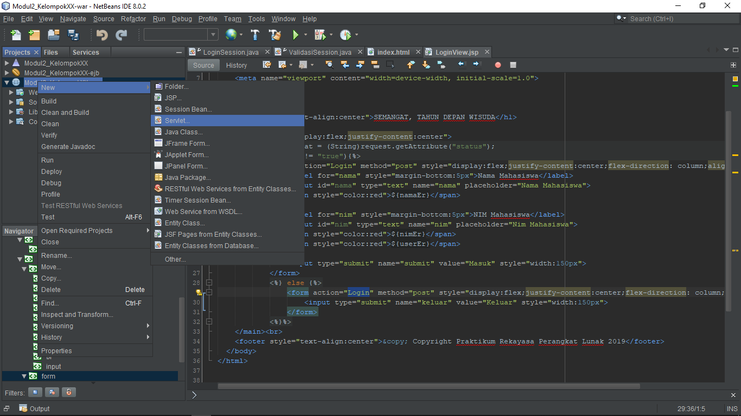

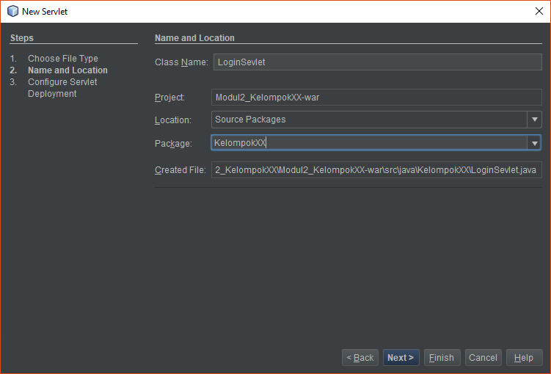

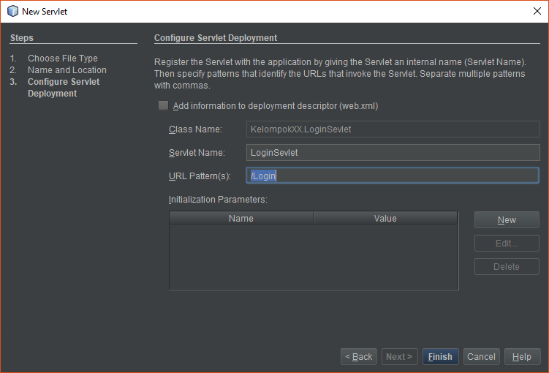

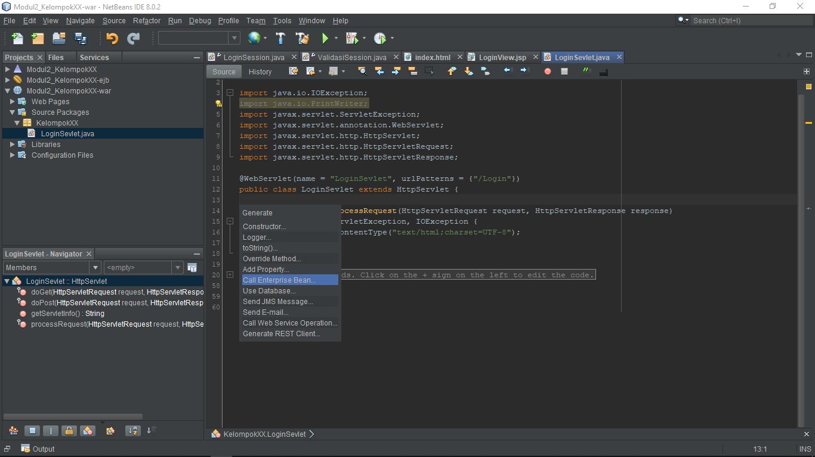

|  |
| --- |
| validasiSession = new ValidasiSession();    request.setAttribute("status", "false");  RequestDispatcher rd = getServletContext().getRequestDispatcher("/LoginView.jsp");  rd.forward(request, response); |

|  |
| --- |
| if("Keluar".equals(request.getParameter("keluar"))){  loginSession.setLoginStatus(false);  request.setAttribute("nimEr", "");  request.setAttribute("namaEr", "");  } |

|  |
| --- |
| String nama = request.getParameter("nama");  String nim = request.getParameter("nim");  boolean stNama, stNim = false;  stNama = validasiSession.nama(nama);  stNim = validasiSession.nim(nim);  if (stNim && stNama){  if (loginSession.Login(nama, nim)) {  loginSession.setLoginStatus(true);  } else {  request.setAttribute("userEr", "Mahasiswa tidak terdaftar");  }  }  else{  if (!stNim) request.setAttribute("nimEr", "Inputan Salah");  if (!stNama) request.setAttribute("namaEr", "Inputan Salah");  }    if (loginSession.isLoginStatus()) {  request.setAttribute("status", "true");  RequestDispatcher rd = getServletContext().getRequestDispatcher("/LoginView.jsp");  rd.forward(request, response);  } else {  request.setAttribute("status", "false");  RequestDispatcher rd = getServletContext().getRequestDispatcher("/LoginView.jsp");  rd.forward(request, response);  } |